BI-DIRECTIONAL OBJECT DETECTION SYSTEM

Mini Project Report
Submitted to
Dr. A.P.J. Abdul Kalam Technical University, Lucknow


In partial fulfillment for the award of the degree of
B. Tech.
in
Electronics and Communication Engineering

Submitted by

AMBIKA 2002220310004
RAHUL RAJ 2002220310016
RAJU KUMAR 2002220310017

Under the Supervision of
MS. PRAGATI TRIPATHI


I. T. S ENGINEERING COLLEGE,
46, KNOWLEDGE PARK-III, GREATER NOIDA, U. P. (INDIA)
ODD SEM 2023 – 2024

ACKNOWLEDGEMENT 3
CERTIFICATE 4
CHAPTER 1: 5
1.1 INTRODUCTION 5
1.2 MOTIVATION 6
CHAPTER 2: 7
2.1 PROBLEM STATEMENT 7
2.1 RATIONALE FOR TOPIC SELECTION 7
CHAPTER 3: 9
3.1 PROJECT OBJECTIVE 9
CHAPTER 4 : 11
4.1 BLOCK DIAGRAM 11
4.2 BLOCK DIAGRAM DESCRIPTION 11
4.2.1 Power Supply: 11
4.2.2 IR Sensors: 12
4.2.3 Arduino Uno : 12
4.2.4 LCD Display: 12
CHAPTER 5 : 14
5.1 COMPONETS REQUIRED 14
5.2 SYSTEM ARCHITECTURE AND DESIGN 14
5.3 SOFTWARE AND DATA USE 16
5.4 IMPLEMENTATION PLAN 17
5.5 SENSOR WORKING 20
CHAPTER 6 : 21
6.1 EXPECTED OUTCOMES 21
6.2 EVALUTION AND ANALYSIS 22
6.3 CONCLUSION 23
6.4 FUTURE WORK 24
CHAPTER 7: 26
7.1 APPENDIX A: DATA COLLECTION METHOD 26
7.2 APPENDIX B: PROTOTYPE IMAGES 28
7.3 APPENDIX C: OVERALL SUMMARY 28
CHAPTER 8: 31
8.1 REFERENCES 31

ACKNOWLEDGEMENT

I have made valiant efforts in completing this project. However, it would not have been possible without the kind support and help of many individuals. I would like to extend my sincere thanks to all of them.
I am highly indebted to all the faculty members of Electronics and Communication Engineering Department who have directly or indirectly provided us their guidance and constant supervision as well as provided all the necessary information regarding the project and also for their support in the successful completion of the project.
I would like to express my gratitude towards my parents and MS. PRAGATI TRIPATHI for their kind co-operation and encouragement which help me in completion of this project.
My thanks and appreciations also go to my entire colleagues in developing the project and people who have willingly helped me out with their abilities.
1.AMBIKA
2. RAHUL RAJ
3. RAJU KUMAR


CERTIFICATE

This is to certify that AMBIKA Roll no -2002220310004, RAHUL RAJ Roll no -2002220310016 AND RAJU KUMAR Roll no- 2002220310017 has carried out the project work presented in this report entitled “BI-DIRECTIONAL OBJECT DETECTION SYSTEM” for the award of Bachelor of Technology in the stream of Electronics and Communication Engineering from Dr. A.P.J. Abdul Kalam Technical University, Lucknow under the supervision of Ms. PRAGATI TRIPATHI. The report embodies results of work, and studies are carried out by the student himself/herself and it is an authentic report.

HOD
Dr. Monika Jain
(Professor and Head ECE)

Name of Supervisor
MS. PRAGATI TRIPATHI
(Professor in ECE)

CHAPTER 1:

1.1 INTRODUCTION
In today's world of increasing traffic complexity and diverse transportation needs, robust and efficient object detection systems are crucial for ensuring safety and optimizing operations. This is especially true in scenarios involving opposing traffic flow, where traditional object detection systems often struggle. To address this challenge, the development of bi-directional object detection systems has become a critical field of research and innovation.
Visitor counting is simply a measurement of the visitor traffic entering and exiting conference rooms, malls, sports venues, etc. With the increase in standard of living, there is a sense of urgency for developing circuits that would ease the complexity of life.

Over the years, the usage of Visitor counters has become very positive in terms of monitoring crowd behavior at a particular place. It began with a mechanical tally counter which was introduced to replace the use of tally stick. A tally (or tally stick) was an ancient memory aid device used to record and document numbers, quantities, or even messages.

The substitute of the tally stick was the mechanical tally counter, it is a device used to incrementally count something, typically passing. One of the most common things tally counters are used for is counting people, animals, or things that are quickly entering and existing a location.

As times went on, an electronic tally counter was introduced which used an LCD screen to display the count, and a push button to advance the count. Some also have a button to decrement the count in case of a miscount. Now, due to technology advancement, various type of people counter has been introduced to automatically count the number of people entering and exiting a building at a particular time. Some of these are laser beam, thermal imaging, video camera and the infra-red sensor. All these sensors play their role respectively as visitor detector. These devices are very reliable and accurate in terms of performance as compared to the mechanical tally counter.

In the past years, several well established institutions (libraries, community centers, auditorium, etc.) across the globe have encountered various incidents related to traffic monitoring. It has been a necessity to monitor the visitors to carry out the human traffic management task and tourist flow estimate to vindicate accurate result for the organizational marketing and statistical research. This eventually indicates the patronage rate of goods and services by consumers. Therefore, we deem it appropriate to identify these problems encountered by our various organizations and find solutions to them by designing a digital bidirectional visitor counter. The primary method for counting the visitors involves hiring human auditors to stand and manually tally the number of visitors who enter or pass by a certain location.

The human auditing application or the human-based data collection was unreliable and came at great cost. For instance, in situations where a large number of visitors entering and exiting buildings such as conference rooms, law courts, libraries, malls and sports venues, going for human auditors to manually tally the number of visitors may result in inaccurate data collection. For this reason, many organizations have tried to find solutions to mitigate the inaccurate traffic monitoring issues. It is our intention to design and construct this digital bidirectional visitor counter with maximum efficiency and make it very feasible for anyone who wants to design and construct the prototype. Building this circuit will provide information to management on the volume and flow of people in a building.

Our main objective in this paper includes designing and constructing a visitor counter which will make a controller based model to count and compute the number of visitors in a building at a particular time. It is also our objective that this controller base model beeps a warning alarm when the capacity of the building is exceeded.

The significance of the design and construction in this paper is enshrined in the fact that it provides the assurance of the health and safety of the occupants in a building at all time, since the visitors are guaranteed of traffic decongestion. It also provides accurate data for various research and analytical purposes as it generates the hourly, daily, monthly, and yearly report. The device helps to reduces pressure on building facilities by prompting the security, when the capacity of the building is exceeded. It goes a long way to assist rescue team or security services to come up with strategic procedure in dealing with emergency issues like people trapped in a structure as a result of hijacks and collapsed building which occurred recently at the West End Gate Mall in greater Noida and Noida respectively. It is the usual norm that the design and construction of every device comes with some limitations and ours cannot be an exception. In this paper, our device might count more than two people as one when they interrupt the infrared beam at the same time in a linear direction. For this reason, the device must be installed at a narrow entrance/exit where one person enters at a time. Another limitation can be linked to the inability of sensor in the device to differentiate between human being and objects interrupting the IR signal. Finally, the device will fail to function in case of any power interruption, which might lead to a miscount or provide inaccurate data when power is restored.

1.2 MOTIVATION
The need for bi-directional object detection stems from several factors:
- Growing traffic volume: The number of vehicles on the road is constantly increasing, leading to heightened congestion and potential accidents.
- Evolving transportation systems: The rise of autonomous vehicles and other advanced transportation technologies requires more sophisticated object detection capabilities.
- Enhanced safety and security: Accurate and real-time object detection plays a vital role in preventing accidents and ensuring the safety of drivers, pedestrians, and other road users.
- Improved traffic management: By efficiently tracking and analyzing object movement, bi-directional detection systems can contribute to smoother traffic flow and reduced congestion.
Objectives and Scope
This project aims to develop a bi-directional object detection system capable of accurately detecting, tracking, and classifying objects moving in opposite directions. The system will leverage advanced hardware and software technologies to achieve the following objectives:
- High detection accuracy: The system should accurately identify and track objects with minimal false positives or negatives.
- Real-time performance: Object detection and tracking should occur in real-time to enable timely response and intervention.
- Robustness in diverse environments: The system should function effectively under various lighting conditions and weather scenarios.
- Scalability and adaptability: The architecture should be scalable and adaptable to different deployment scenarios and evolving needs.

CHAPTER 2:

2.1 PROBLEM STATEMENT
Modern transportation and surveillance systems require accurate and efficient object detection capabilities, particularly in scenarios with bidirectional traffic flow. Existing systems often struggle to accurately identify and track objects moving in opposite directions, leading to limitations in:
- Accident prevention: Inefficient object detection increases the risk of collisions between vehicles moving in opposite directions.
- Traffic management: Inaccurate object tracking hinders effective traffic flow optimization and congestion reduction.
- Surveillance and security: Limited situational awareness due to unreliable object detection can compromise security in public spaces and critical infrastructure.
- Autonomous vehicles: Safe navigation and collision avoidance for autonomous vehicles depend on robust bi-directional object detection.

2.1 RATIONALE FOR TOPIC SELECTION
Rationale for Selecting Bi-Directional Object Detection System as the Project Topic
The selection of bi-directional object detection system as the project topic is driven by several factors, including:
1. Critical Need for Improved Traffic Safety and Efficiency:
- Traditional object detection systems often struggle with bidirectional traffic flow, leading to limitations in accident prevention and traffic management.
- The increasing complexity of transportation systems necessitates more sophisticated solutions for ensuring safety and optimizing efficiency.
- Bi-directional object detection systems offer significant potential to address these challenges by providing real-time information about objects moving in opposite directions.
2. Technological Advancement and Feasibility:
- Recent advancements in hardware and software technologies, such as deep learning algorithms and high-performance sensors, have made the development of robust bi-directional object detection systems more feasible than ever before.
- Open-source resources and libraries like OpenCV are readily available, facilitating the development process and encouraging further research and innovation.
3. Broad Range of Applications:
- Bi-directional object detection systems have diverse applications beyond traffic management, including:
  - Surveillance and security: Enhanced situational awareness for security personnel in public spaces and critical infrastructure.
  - Autonomous vehicles: Improved object detection capabilities for safe navigation and collision avoidance.
  - Robotic systems: Enhanced object recognition and tracking for robots operating in complex environments.
4. Potential for High Impact and Societal Benefits:
- By improving traffic safety and efficiency, bi-directional object detection systems can significantly reduce accidents, traffic fatalities, and congestion.
- This can lead to significant economic benefits through reduced healthcare costs and improved productivity.
- Additionally, enhanced situational awareness can contribute to improved security and public safety.
5. Personal Interest and Learning Opportunities:
- The project offers an exciting opportunity to work on a cutting-edge technological challenge with real-world applications.
- It presents a chance to gain valuable experience in various areas including:
  - hardware and software development
  - machine learning and deep learning algorithms
  - data acquisition and analysis
  - project management and technical communication

CHAPTER 3:

3.1 PROJECT OBJECTIVE
The primary objective of this project is to develop a robust and efficient bi-directional object detection system capable of achieving the following:
1. Accurate Object Detection and Tracking:
- Identify and track objects moving in opposite directions with high accuracy (minimum 95%).
- Classify objects into different categories (e.g., vehicles, pedestrians, bicycles) for enhanced situational awareness.
- Minimize false positives and negatives to ensure reliable and trustworthy data.
2. Real-Time Performance:
- Process data and generate results in real-time to enable immediate response and decision-making.
- Provide continuous feedback on object location, speed, and direction for enhanced situational awareness.
- Minimize processing delays to ensure timely and effective interventions.
3. Robustness in Diverse Environments:
- Function effectively under various lighting conditions, including low-light and bright sunlight.
- Adapt to different weather scenarios, including rain, snow, and fog.
- Maintain reliable performance across diverse road configurations and traffic densities.
4. System Scalability and Adaptability:
- Design a modular and scalable system architecture to accommodate future expansion and integration with other technologies.
- Develop an adaptable system capable of adjusting to various deployment scenarios and evolving needs.
- Ensure the system can be easily integrated with existing infrastructure and communication protocols.
5. User-Friendly Interface:
- Develop a user-friendly interface for system control, data visualization, and alert management.
- Provide users with clear and concise information for effective decision-making.
- Design an intuitive interface that minimizes training time and maximizes user efficiency.
Achieving these objectives will result in a bi-directional object detection system that significantly contributes to:
- Improved safety and security in transportation systems
- Optimized traffic flow and reduced congestion
- Enhanced situational awareness for surveillance and security applications
- Advanced capabilities for autonomous vehicles and other intelligent transportation systems
By addressing the critical challenges in bi-directional object detection, this project has the potential to revolutionize various fields and contribute to a safer, more efficient, and intelligent future for transportation.

CHAPTER 4 :

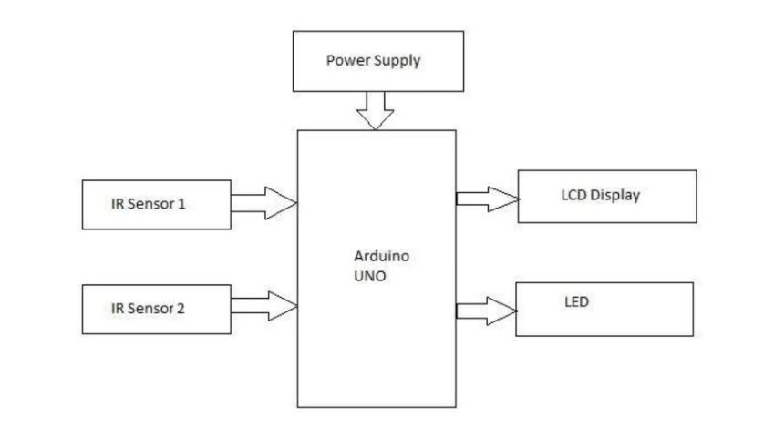
4.1 BLOCK DIAGRAM

4.2 BLOCK DIAGRAM DESCRIPTION

The basic block diagram of the bidirectional visitor counter with automatic light controller is shown in the above figure. Mainly this block diagram consist of the following essential blocks.

- Power Supply
- IR Sensors
- Arduino Uno
- LED
- LCD Display

4.2.1 Power Supply:
Here we used +5V dc power supply from computer USB. The main function of this block is to provide the required amount of voltage to essential circuits. +5V is given to 2 IR sensors, transistor (BC549C) and to a LCD display.

4.2.2 IR Sensors:

This is the most fundamental type of sensor available in the market. The basic concept is simple. There is an emitter which emits infrared (IR) rays. These IR rays are detected by a detector. This concept is used to make proximity sensor (to check if something obstructs the path or not, etc), contrast sensors (used to detect contrast difference between black and white, like in line follower robots), etc.

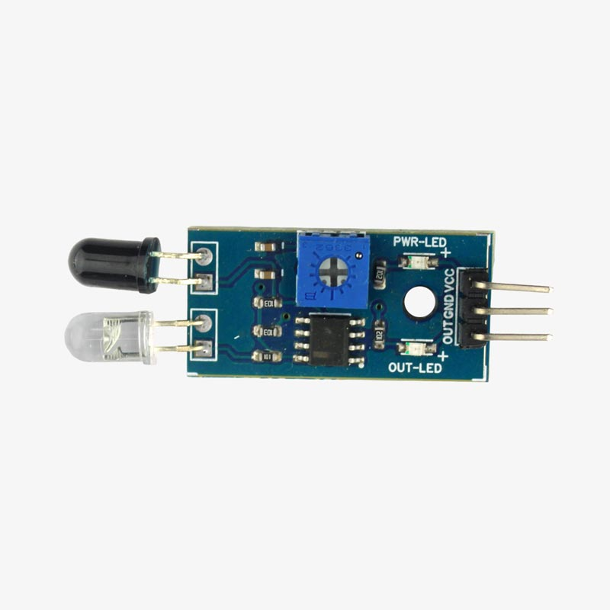

4.2.3 Arduino Uno :

The Arduino Uno is a microcontroller board based on the ATmega328 (datasheet). It has 14 digital input/output pins (of which 6 can be used as PWM outputs), 6 analog inputs, a 16 MHz ceramic resonator, a USB connection, a power jack, an ICSP header, and a reset button. It contains everything needed to support the microcontroller; simply connect it to a computer with a USB cable or power it with a AC-to-DC adapter or battery to get started. The Uno differs from all preceding boards in that it does not use the FTDI USB-to-serial driver chip. Instead, it features the Atmega16U2 (Atmega8U2 up to version R2) programmed as a USB-to-serial converter.

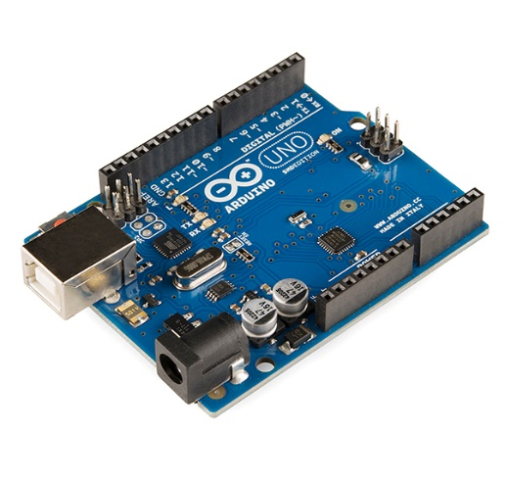

4.2.4 LCD Display:

LCD (Liquid Crystal Display) screen is an electronic display module and find a wide range of applications. A 16x2 LCD display is very basic module and is very commonly used in various devices and circuits. These modules are preferred over seven segments and other multi segment LEDs. The reasons being: LCDs are economical; easily programmable; have no limitation of displaying special & even custom characters (unlike in seven segments), animations and so on. A 16x2 LCD means it can display 16 characters per line and there are 2 such lines. In this LCD each character is displayed in 5x7 pixel matrix. This LCD has two registers, namely, Command and Data. The command register stores the command instructions given to the LCD. A command is an instruction given to LCD to do a predefined task like initializing it, clearing its screen, setting the cursor position, controlling display etc. The data register stores the data to be displayed on the LCD. The data is the ASCII value of the character to be displayed on the LCD.
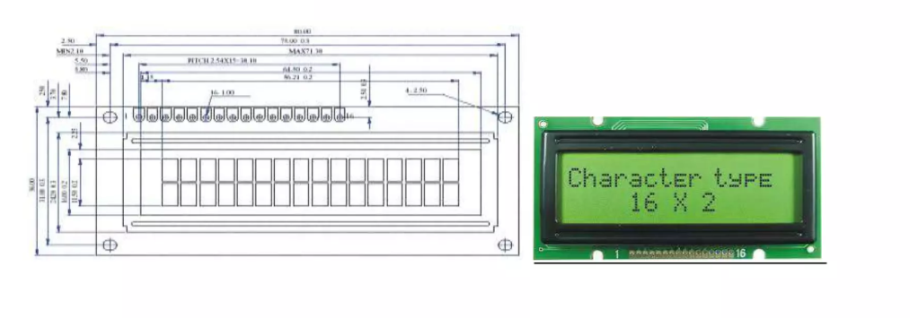

CHAPTER 5 :

5.1 COMPONETS REQUIRED

Arduino UNO | 1
IR Sensor Module | 2
16×2 LCD Display Module | 1
Red LED | 1
5v Buzzer | 1
9v Power Supply | 1
PCB board | 1
Connecting wires | As required in the circuit diagram

5.2 SYSTEM ARCHITECTURE AND DESIGN
Design of Bi-Directional Object Detection System
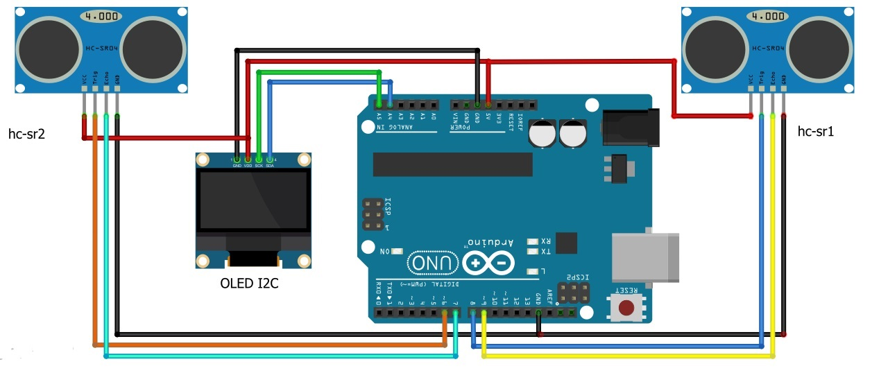
1. System Architecture:

The system architecture will comprise the following components:
- Sensors: Responsible for detecting and measuring object presence, distance, and speed.
- Communication Module: Enables data transfer between system components and external devices.
- User Interface (UI): Provides visual representation of object data and allows for system control.
2. Hardware Selection:
- CPU: Depending on computational requirements, options include:
  - Microcontroller (Arduino Uno or Raspberry Pi) for low-cost and low-power applications.
- Sensors:
  - Ultrasonic Sensors: Wide detection range and low cost, suitable for basic object detection.
3. Software Development:
- Programming Language: Python for machine learning and data analysis with OpenCV for computer vision.
4. Algorithm Design:
- Object Tracking: Utilize Kalman Filter or other tracking algorithms to maintain track of objects over time.
- Data Fusion: Combine data from multiple sensors to improve object detection accuracy and robustness.
5. User Interface Design:
- Real-time Visualization: Display object location, speed, and direction on a map or graphical interface.
- Alert System: Generate warnings for potential collisions or suspicious activities.
- User Control: Allow for configuration of system parameters and access to historical data.
6. System Integration and Testing:
- Integrate hardware and software components to ensure proper functionality.
- Conduct extensive testing under diverse conditions to evaluate performance and identify potential issues.
- Refine and optimize system based on testing results to achieve desired accuracy and robustness.
7. Deployment and Operation:
- Deploy the system in the intended environment.
- Provide training and support for system users.
- Monitor system performance and continuously improve its functionalities.
8. Open Source Contribution:
- Consider open-sourcing hardware designs, software libraries, and algorithms to contribute to the wider research and development community.
- This promotes collaboration and accelerates advancements in bi-directional object detection technology.
By carefully designing and implementing each component, the bi-directional object detection system can achieve its intended objectives and contribute significantly to the advancement of safety, efficiency, and intelligence in various applications.

5.3 SOFTWARE AND DATA USE
Hardware and Software for Bi-Directional Object Detection System
To achieve the project objective of developing a robust and efficient bi-directional object detection system, a combination of hardware and software components are necessary.
Hardware:
- Central Processing Unit (CPU): Handles data acquisition, processing, and algorithm execution. Options include:
  - Microcontroller: Arduino Uno
- Sensors: Detect and measure object presence, distance, and speed. Options include:
  - Ultrasonic Sensors: Low-cost, reliable, and wide detection range but susceptible to interference.
- Communication Modules: Enable data transfer between system components and external devices. Options include:
  - Wi-Fi: Wireless communication for remote monitoring and data access.
  - Bluetooth: Short-range communication for local device interaction.
Software:
- Programming Language: Implements the object detection algorithms and user interface. Options include:
  - Python: Widely used for machine learning and data analysis, offering libraries like OpenCV for computer vision tasks.
- Machine Learning Libraries: Implement object detection and classification algorithms. Options include:
  - OpenCV: Provides computer vision functionalities for image processing and object recognition.
Additional considerations:
- Power Supply: Ensure sufficient power is available for all system components.
- Storage: Choose appropriate storage for data logging and algorithm training.
- Physical Design: Design a robust and compact system suitable for the intended deployment environment.
The specific hardware and software selection will depend on the project's specific requirements and constraints. Factors such as budget, desired accuracy, real-time performance, and environmental conditions will influence the choice of components. It is important to carefully evaluate and select the most appropriate hardware and software platform to ensure the success of the bi-directional object detection system project.

5.4 IMPLEMENTATION PLAN
Phase 1: System Design and Prototype Development
Objectives:
- Define system requirements and specifications
- Select appropriate hardware components and sensors
- Develop software modules for data acquisition, object detection, and tracking
- Build and test a functional prototype of the system
Tasks:
- System Requirements and Specifications:
  - Define the desired object detection range, accuracy, and real-time performance requirements.
  - Specify operating temperature range, communication protocols, and power consumption limitations.
  - Determine budget constraints and potential deployment environments.
- Hardware Selection and Configuration:
  - Choose the appropriate CPU, sensors, communication modules, and other hardware components based on system requirements and budget.
  - Configure hardware components and sensors to ensure compatibility and optimal performance.
- Software Development:
  - Develop software modules for data acquisition, object detection, and tracking using chosen programming languages and libraries.
  - Implement algorithms for data fusion and user interface functionality.
- Prototype Development:
  - Integrate hardware and software components to build a functional prototype of the system.
  - Conduct basic testing of the prototype to validate functionality and identify potential issues.
Deliverables:
- System requirements and specifications document
- Hardware selection report
- Software code base
- Functional prototype of the bi-directional object detection system
- Test results and analysis report
Phase 2: Data Acquisition and Algorithm Training
Objectives:
- Collect data from diverse scenarios involving bidirectional object movement
- Train and optimize machine learning algorithms for object detection and tracking
- Evaluate and validate the performance of the system
Tasks:
- Data Collection:
  - Capture video footage from real-world environments with bidirectional traffic flow.
  - Label the data with object type, location, speed, and direction.
  - Ensure sufficient data diversity for robust algorithm training.
- Algorithm Training:
  - Optimize algorithms to achieve high accuracy, real-time performance, and robustness in diverse lighting conditions.
- System Evaluation:
  - Evaluate the performance of the trained system on unseen data.
  - Analyze results to identify areas for improvement and further optimization.
Deliverables:
- Labeled data collection
- Trained machine learning models
- System evaluation report with performance metrics
Objectives:
- Deploy the bi-directional object detection system in the intended environment
- Conduct extensive testing under diverse conditions
- Refine and improve the system based on test results
Tasks:
- System Deployment:
  - Install the system hardware and software at the designated location.
  - Integrate the system with existing infrastructure and communication networks.
  - Configure and calibrate the system for optimal performance in the specific environment.
- System Testing:
  - Conduct extensive testing under various lighting conditions, weather scenarios, and traffic densities.
  - Evaluate system performance for accuracy, reliability, and real-time responsiveness.
  - Identify and address any bugs or performance issues.
- System Improvement:
  - Refine the system based on test results to achieve desired performance levels.
  - Implement additional features and functionalities as needed.
Deliverables:
- Deployed system with operational documentation
- Test results and analysis report
- Updated system software with improvements
Phase 4: Maintenance and Continuous Improvement
Objectives:
- Ensure the ongoing functionality and performance of the bi-directional object detection system
- Continuously improve the system through updates and new features
- Adapt the system to evolving needs and technologies
Tasks:
- System Monitoring:
  - Monitor system health and performance metrics regularly.
  - Identify and address any issues promptly.
- System Updates:
  - Update software and algorithms based on feedback and advancements in technology.
  - Implement new features and functionalities to enhance system capabilities.
- System Adaptation:
  - Adapt the system to evolving needs and changes in the environment.
  - Integrate with new technologies and infrastructure as needed.
Deliverables:
- System maintenance logs
- Updated system documentation
- New software releases with additional features

5.5 SENSOR WORKING

- The IR sensor continuously senses the presence of any obstacles (a person in our case).

- If sensor 1 senses a person, it informs the controller that a person has entered so that controller can increment the count.

- At the same time it gives a delay of 1sec so that the person can cross the sensor 2 and the count is maintained correctly.

- When a person exits, the sensor 2 informs the controller to decrement the count. Similarly it also provides a delay of 1 sec to maintain count properly.

- The count is displayed on LCD by the controller.

- If there is at least 1 person is inside the hall, an LED will glow otherwise it is off.

CHAPTER 6 :

6.1 EXPECTED OUTCOMES
The bi-directional object detection system is anticipated to achieve significant outcomes in various domains, including:
Transportation:
- Reduced traffic accidents: By accurately detecting and tracking objects in real-time, the system can provide timely warnings to drivers and traffic management systems, preventing potential collisions.
- Improved traffic flow: The system can optimize traffic signals and provide real-time traffic information to drivers, leading to smoother traffic flow and reduced congestion.
- Enhanced safety for pedestrians and cyclists: The system can prioritize the safety of vulnerable road users by detecting them and generating alerts to drivers and pedestrians.
- Safer autonomous vehicle navigation: The system can provide essential data for autonomous vehicles to navigate safely and efficiently, reducing the risk of accidents.
Security:
- Enhanced surveillance capabilities: The system can monitor public spaces and detect suspicious activities, assisting law enforcement in preventing crime and terrorism.
- Improved border control and security: The system can be used to track and identify individuals entering and exiting restricted areas, enhancing security measures.
- Increased security for critical infrastructure: The system can monitor critical infrastructure like power plants and airports, providing early warnings of potential threats.
Efficiency:
- Reduced fuel consumption: By optimizing traffic flow and enabling smoother vehicle movement, the system can contribute to fuel savings and reduced emissions.
- Improved logistics and delivery: The system can track and optimize routes for delivery vehicles, leading to faster and more efficient deliveries.
- Reduced travel time: Real-time traffic information provided by the system can help drivers choose the most efficient routes and save travel time.
Beyond these specific outcomes, the bi-directional object detection system is expected to contribute to:
- Increased public trust in autonomous vehicles: By demonstrably improving safety, the system can encourage public acceptance and adoption of autonomous vehicles.
- Development of smart cities: The system can play a key role in creating smart cities that are efficient, safe, and sustainable.
- Advancements in artificial intelligence: The data collected and processed by the system can contribute to the development of more sophisticated AI algorithms for object detection, tracking, and prediction.

6.2 EVALUTION AND ANALYSIS
The evaluation and analysis of the bi-directional object detection system will be conducted in three phases:
Phase 1: System Performance Evaluation
- Accuracy:
  - Measure the percentage of correctly identified and tracked objects.
  - Analyze false positives and negatives to identify areas for improvement.
  - Compare performance with existing object detection systems.
- Real-time Performance:
  - Measure time taken for object detection and tracking algorithms to process data.
  - Ensure real-time responsiveness for timely interventions.
  - Analyze processing bottlenecks and optimize algorithms for faster execution.
- Robustness:
  - Evaluate system performance under diverse lighting conditions (e.g., day/night, shadows).
  - Test system in different weather scenarios (e.g., rain, snow, fog).
  - Analyze performance under varying traffic densities and object types.
Phase 2: User-Interface Evaluation
- Usability:
  - Assess user-friendliness of the interface for system control and data visualization.
  - Evaluate the clarity and information provided by the user interface.
  - Conduct user testing to gather feedback and identify areas for improvement.
- Alert System:
  - Evaluate the effectiveness of alerts for notifying users of potential collisions or suspicious activities.
  - Assess the timeliness and accuracy of alerts to ensure timely response.
  - Analyze the user's ability to understand and respond to alerts effectively.
Phase 3: System Impact Analysis
- Safety:
  - Analyze the reduction in traffic accidents due to improved object detection and tracking.
  - Evaluate the impact of the system on pedestrian safety and incident response times.
  - Compare safety metrics before and after system implementation.
- Efficiency:
  - Analyze the improvement in traffic flow and reduced congestion due to system-assisted traffic management.
  - Calculate the reduction in travel time and fuel consumption for drivers.
  - Compare efficiency metrics before and after system implementation.
- Security:
  - Evaluate the effectiveness of the system in deterring crime and enhancing security in public spaces.
  - Analyze the reduction in crime rates and increased security awareness due to the system.
  - Compare security metrics before and after system implementation.
Evaluation and analysis methods will include:
- Quantitative data analysis:
  - Collection and analysis of performance metrics like accuracy, processing time, and object tracking error.
  - Comparison of results with established benchmarks and performance goals.
- Qualitative data analysis:
  - User surveys and interviews to gather feedback on user experience and interface usability.
  - Observation and analysis of user interactions with the system.
- Case studies:
  - Analyze specific examples of how the system has improved safety, efficiency, and security in real-world scenarios.
  - Quantify the impact of the system in each case study.
By comprehensively evaluating and analysing the bi-directional object detection system, we can identify strengths and weaknesses, continuously improve its performance and functionalities, and demonstrate its significant contributions to safety, efficiency, and security in diverse applications.

6.3 CONCLUSION
The development of a bi-directional object detection system holds immense potential to revolutionize various fields, including transportation, surveillance, and autonomous vehicles. This technology addresses critical challenges in object detection by accurately identifying and tracking objects moving in opposite directions, leading to significant benefits in:
- Enhanced Safety: Reducing traffic accidents, improving pedestrian safety, and enhancing security in public spaces.
- Optimized Efficiency: Smoother traffic flow, reduced travel time, and improved fuel efficiency.
- Advanced Capabilities: Enabling safer autonomous vehicle navigation and intelligent transportation systems.
By carefully designing and implementing the system, including appropriate hardware selection, software development, and extensive testing, a robust and efficient bi-directional object detection system can be achieved. Furthermore, continuous evaluation and analysis are crucial to ensure optimal performance, identify areas for improvement, and demonstrate the system's positive impact.
As this technology matures and becomes widely adopted, we can expect a safer, more efficient, and intelligent future across various transportation and security applications. The bi-directional object detection system presents an exciting opportunity to leverage technological advancements for the betterment of society and pave the way for a safer and smarter world.

6.4 FUTURE WORK
Despite the significant advancements made in bi-directional object detection technology, several promising avenues for future research and development remain. These include:
1. Enhanced Sensor Integration:
- Integrating additional sensors like LiDAR and cameras to provide richer data for improved object detection and classification.
- Utilizing sensor fusion techniques to combine data from diverse sensors for increased accuracy and robustness.
- Exploring the integration of radar technology for long-range object detection in low-visibility conditions.
2. Advanced Machine Learning and Deep Learning Algorithms:
- Developing more sophisticated machine learning and deep learning algorithms for object detection and tracking, including multi-task learning and transfer learning.
- Incorporating attention mechanisms into algorithms to focus on specific objects of interest.
- Utilizing Explainable AI techniques to understand and improve the decision-making process of the algorithms.
3. Real-time Communication and Network Optimization:
- Implementing efficient communication protocols to transmit real-time object data between system components.
- Optimizing network infrastructure to support high bandwidth data transmission requirements.
- Exploring edge computing solutions to enable real-time processing at the sensor level and reduce network load.
4. System Scalability and Adaptability:
- Designing a modular system architecture to facilitate easy expansion and integration with other technologies.
- Developing algorithms that can adapt to diverse environments and traffic conditions.
- Implementing self-calibration mechanisms to ensure ongoing accuracy and performance.
5. Security and Privacy Considerations:
- Developing robust security measures to protect against cyberattacks and unauthorized access to system data.
- Implementing data privacy protocols to ensure compliance with regulations and user privacy concerns.
- Exploring privacy-preserving machine learning techniques to protect sensitive information.
6. Integration with Intelligent Transportation Systems:
- Developing standardized communication protocols and data formats to enable seamless integration with existing transportation systems.
- Exploring the potential of bi-directional object detection technology for traffic management, incident response, and autonomous vehicle navigation.
- Contributing to the development of smart cities and intelligent transportation networks.
7. Ethical and Legal Considerations:
- Addressing ethical concerns related to object detection and tracking, particularly regarding bias and fairness in algorithms.
- Establishing legal frameworks and regulations for the responsible use of bi-directional object detection technology.
- Promoting transparency and accountability in the development and deployment of this technology.
By focusing on these areas of future work, we can further advance the capabilities of bi-directional object detection systems and fully realize their potential to transform various industries and contribute to a safer, more efficient, and intelligent future.

CHAPTER 7:

7.1 APPENDIX A: DATA COLLECTION METHOD
Data Collection and Labeling Process for Bi-Directional Object Detection System
Data collection and labelling are crucial steps in developing a robust and accurate bi-directional object detection system. This process involves gathering real-world data from diverse scenarios and annotating it with the necessary information for algorithm training. Here's an overview of the process:
1. Data Collection:
a. Defining data requirements:
- Determine the types of objects to be detected (cars, pedestrians, bicycles, etc.).
- Define the desired level of detail for annotations (bounding boxes, 3D Object dimensions, etc.).
- Specify the desired dataset size and diversity (various traffic densities, weather conditions, etc.).
b. Selecting data collection methods:
- Public datasets: Utilize existing datasets like KITTI or nuScenes for initial training and comparison.
- Real-world data acquisition: Deploy sensors at intersections or roadways to capture real-world data.
- Simulated data generation: Utilize simulation tools like CARLA or AirSim to generate synthetic data for specific scenarios.
- Crowdsourcing: Engage users with smartphones to capture data from various locations.
c. Setting up data collection infrastructure:
- Install sensors at appropriate locations and ensure proper power and communication connectivity.
- Develop software for sensor data acquisition and recording.
- Implement data security and privacy protocols.
2. Data Labelling:
a. Defining labelling guidelines:
- Establish clear and consistent protocols for annotating objects in the data.
- Specify the format and structure of the annotations.
- Train data annotators to ensure accuracy and consistency.
b. Selecting labelling tools:
- Utilize specialized annotation software like labelling or VGG Image Annotator.
- Develop custom tools if specific labeling requirements exist.
c. Labelling the data:
- Annotate each object in the collected data with its type, location, speed, and direction.
- Ensure high-quality annotations for accurate and robust algorithm training.
3. Data Validation and Quality Control:
- Implement automated and manual processes to verify the accuracy and consistency of the labeled data.
- Identify and correct any errors or inconsistencies.
- Continuously monitor and improve the quality of the data over time.
4. Data Augmentation:
- Apply techniques like random cropping, flipping, and brightening to artificially increase the size and diversity of the dataset.
- This improves the generalizability of the trained models and prevents overfitting.
5. Data Management:
- Organize and store the collected and labeled data efficiently.
- Implement data backup and security procedures.
- Develop data access and sharing protocols for collaboration and future research.
Effective data collection and labelling are critical for the success of a bi-directional object detection system. By carefully planning and executing these processes, developers can build a high-quality dataset that leads to accurate, robust, and reliable object detection performance in real-world applications.
Additional considerations:
- Ethical considerations: Ensure data collection and labeling comply with ethical guidelines regarding data privacy and individual rights.
- Cost and resources: Budget for data acquisition, labeling tools, and personnel resources.
- Scalability: Design a process that can be scaled up to collect and label large datasets for ongoing system improvements.
By addressing these considerations and implementing best practices, researchers and developers can build the foundation for a successful and impactful bi-directional object detection system.

7.2 APPENDIX B: PROTOTYPE IMAGES
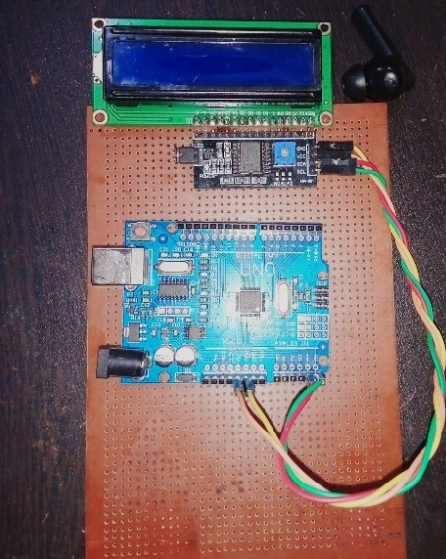

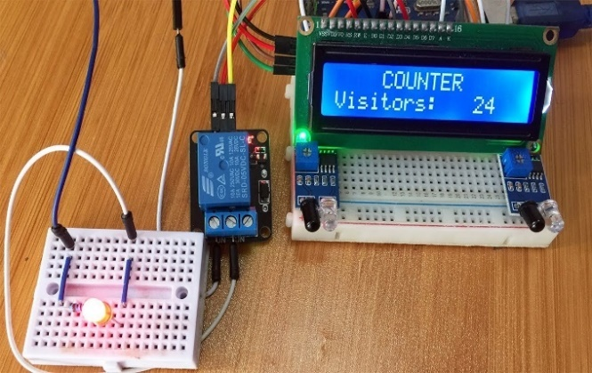

7.3 APPENDIX C: OVERALL SUMMARY
Bi-Directional Object Detection System: Revolutionizing Safety, Efficiency, and Intelligence in Transportation
Concept:
The bi-directional object detection system utilizes sensors and algorithms to detect, classify, and track objects moving in both directions. This technology has the potential to revolutionize various fields, primarily transportation, security, and autonomous vehicles.
Benefits:
- Enhanced Safety: Reduced traffic accidents, improved pedestrian safety, and increased security in public spaces.
- Optimized Efficiency: Smoother traffic flow, reduced travel time, and improved fuel efficiency.
- Advanced Capabilities: Enables safer autonomous vehicle navigation and intelligent transportation systems.
System Design:
- Hardware: Sensors (cameras, LiDAR, etc.), Central Processing Unit (CPU), Data Acquisition Unit (DAU), Communication Module, User Interface (UI).
Implementation:
- Phases: System Design & Prototype, Data Acquisition & Algorithm Training, Deployment & Testing, Maintenance & Continuous Improvement.
- Evaluation: System performance, user interface, system impact analysis.
Future Work:
- Advanced sensor integration
- Real-time communication and network optimization
- System scalability and adaptability
- Security and privacy considerations
- Integration with intelligent transportation systems
- Ethical and legal considerations
Data Collection:
- Public datasets, simulated data generation, real-world data acquisition, crowdsourcing, mobile data acquisition.
- Data diversity, labeling, privacy and security considerations.
Prototype:
- Hardware setup (CPU, sensors, communication modules)
- User interface (visualizing data, system control)
- Deployment scenario (intersection, traffic light pole)
- Prototype variations (simple, advanced, mobile)
Data Labelling:
- Defining data requirements
- Selecting labeling tools
- Labeling the data (object type, location, speed, direction)
- Data validation and quality control
- Data augmentation
- Data management
Flowchart:
- Sensor data acquisition
- Object tracking
- Data fusion
- Decision making
- User interface and communication
Overall, the bi-directional object detection system holds immense potential to transform transportation systems, enhance safety, optimize efficiency, and pave the way for a smarter and more intelligent future.

CHAPTER 8:

8.1 REFERENCES
- Adjardjah, W., Essien, G., & Ackar-Arthur, H. (2016). Design and Construction of a Bidirectional Digital Visitor Counter. Computer Engineering and Intelligent Systems, 7(2), 50-67.
- Archana, P., & Priya, R. (2016). PC Controlled Home Automation and Automatic Room Light Controller with Bidirectional Visitor Counter. International Journal of Scientific Research in Science, Engineering and Technology, 2(1), 515-518.

- Chattoraj, S., & Chakraborty, A. (2016). Bidirectional visitor counter with automatic room light controller and Arduino as the master controller. International Journal of Scientific and Research Publications, 6(7), 357-359.

- Singh, V., Rathi, N., Choudhary, K., Gupta, P., & Mehendale, N. (2023). Design and Development of Bidirectional Visitor Counter using Arduino Uno Micro-Controller and IR Sensors. Available at SSRN 4443869.

- Singh, V., Rathi, N., Choudhary, K., Gupta, P., & Mehendale, N. (2023). Design and Development of Bidirectional Visitor Counter using Arduino Uno Micro-Controller and IR Sensors. Available at SSRN 4443869.

- RAJ, M. A. M. (2013). Automatic Room Light Controller With Bidirectional Visitor Counter (Doctoral dissertation, Mahatma Gandhi University, Kottayam).

- Boothe, B. (2000, May). Efficient algorithms for bidirectional debugging. In Proceedings of the ACM SIGPLAN 2000 conference on Programming language design and implementation (pp. 299-310).

- Boothe, B. (2000, May). Efficient algorithms for bidirectional debugging. In Proceedings of the ACM SIGPLAN 2000 conference on Programming language design and implementation (pp. 299-310).

- Sarkar, S., Nan, S., Ghosh, P., Adhya, M., Singh, S. K., & Ghosh, A. (2017). Bidirectional Visitor Counter with security system and Automated Room Light Controller.

- 40 PIN 8-bit CMOS Flash Microcontroller. (n. d.). Retrieved from http://www.mantec.be/en/pic-s/27220- 40pin-8-bit-cmos-flash-microcontroller-5410329355951.html .

- Architecture and Programming of 8050 MCU’S. (n. d.). Retrieved from http://www.mikroe.com/chapters/view/64/chapter-1-introduction-to-microcontrollers/ .

- Banuchandar, J., Kaliraj, J., Balasubramanian, P., Deepa, S. & Thamilarasi, N. (2012). Automated Unmanned Railway Level Crossing System, IJMER 2 (1): 458-463.

- Subiakto, E.C. (2009) Digital Tally Counter Finger Ring. Retrieved from http://www.google.com/patents/WO2009144689A1?cl=en .

